Dividing the 25 vertices into 2 parts based on the graph shown

1. Running TSp on the first 12 vertices

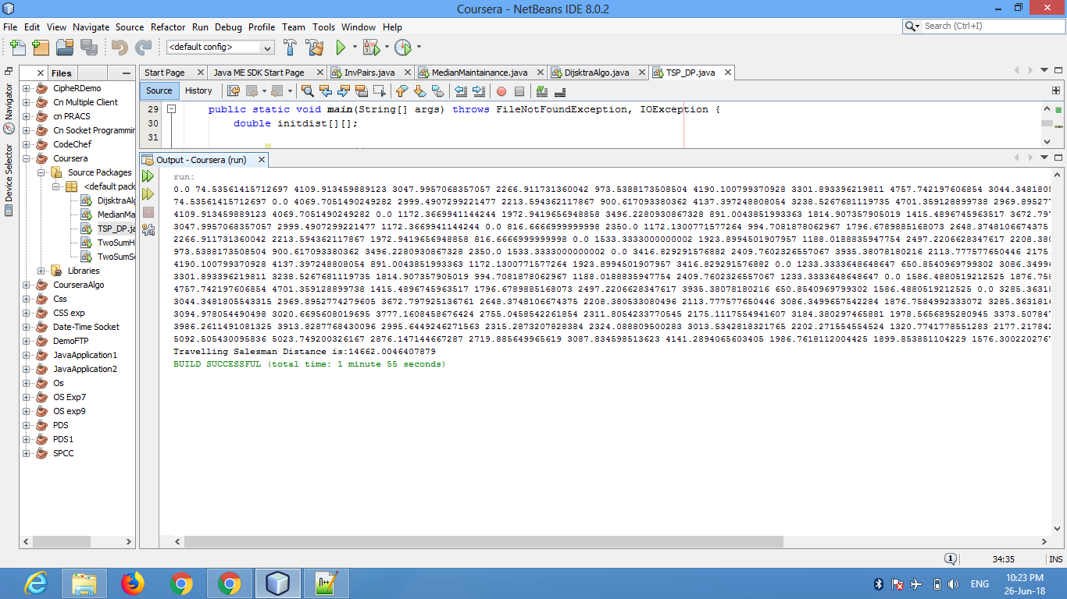

1. Running from the 11th vertex till the 24th vertex

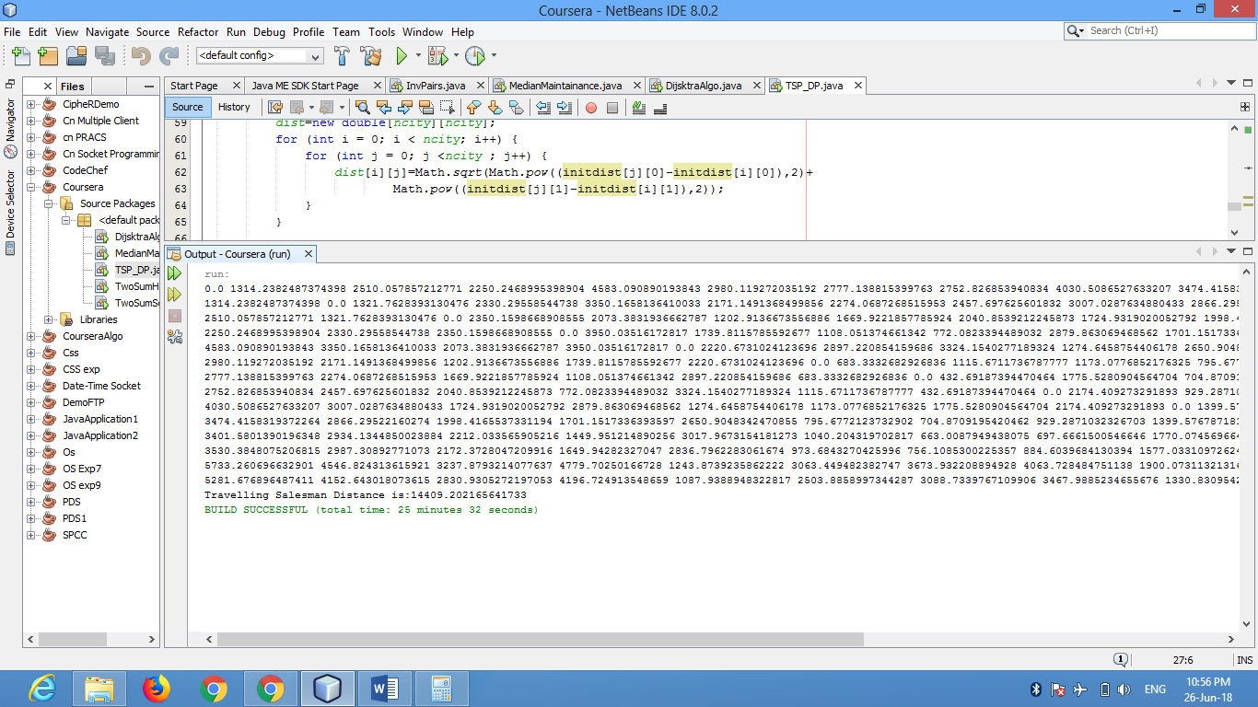

14662

+ 14409

- 1314.238 \* 2

26442